SQL Review Module 01

## Assignment

**Name: Vivek M Panchal**

**Submit this document edited to include your answers, for the six tasks, to the HW#4 Dropbox by the stated deadline.**

**Task #1 (12 points)**

MUSIC(Title, Artist, NumGrpMembers, Year, Producer, ProducerURL,Category, CategorySales, Media, MediaPrice )

Business Rules:

1. Each “album” (CD) is uniquely identified by its title. Note that, for the rest of the business rules, the “Title” attribute of MUSIC refers to the name of the “album”.
2. An artist may either be a single person or a band made up of multiple members (the count being recorded in NumGrpMembers, which can be 1).
3. Each album has one release year.
4. Each album is produced by one music production company (producer).
5. Each producer has one company URL.
6. A specific album has only one artist.
7. Each album is classified into one music category (Rock, Country, etc.)
8. Each category is associated with one category sales value, which is the year-to-date sales for that given category.
9. For convenience, the music company sells all of its music at the same price based on the media type. For example, all cassettes are $9.99, all CDs are $16.99, etc.

List ALL **functional** dependencies for the MUSIC relation above, according only to the business rules listed. Use the format A 🡪 B. Then, for each functional dependency denote with a ‘Y’ or ‘N’ if the respective functional dependency causes 2NF or 3NF violation in the MUSIC relation.

|  |  |  |
| --- | --- | --- |
| **Functional Dependencies** | **2NF violation?** | **3NF violation?** |
| **Artist -> NumGrpMembers** | **N** | **Y** |
| **Title -> Artist , Producer, Year, Category** | **Y** | **N** |
| **Producer -> ProducerUrl** | **N** | **Y** |
| **Category -> CategorySales** | **N** | **Y** |
| **Media -> MediaPrice** | **Y** | **N** |
|  |  |  |
|  |  |  |
|  |  |  |

**Task #2 (9 points)**

For the relation below, determine the *highest* normal form the relation is in, the reason, and if necessary normalize the relation, and all resulting relations, through BCNF. Use proper relational notation and include reference statements for any foreign keys.

Q1( a, b, c, d )

Functional Dependencies:

a, b🡪 c, d

c 🡪 d

**YOUR ANSWER:**

The first functional dependency shows us that **a,b** which are the primary keys determines the other two attributes i.e **c,d**  which indicates that it is atleast in 2NF

The second functional dependency shows us that an attribute **d** is dependent on a nonkey attribute **c** ,so it cannot be in 3NF

Q1(a , b, *c*)

Q1(c) mei Q1B(c)

Q1B(c, d)

**Task #3 (12 points)**

For the relation below, determine the *highest* normal form the relation is in, the reason, and if necessary normalize the relation, and all resulting relations, through BCNF. Use proper relational notation and include reference statements for any foreign keys.

Q2(a, b, c, d)

Functional dependencies:

a, b🡪 c, d

a🡪c

b🡪d

**YOUR ANSWER:**

The first functional dependency shows us that **a,b** which are the primary keys determines the other two attributes i.e **c,d**  which indicates that it is atleast in 2NF unless other dependencies dont create problem.

The second functional dependency shows that a part of primary key i.e **a** determines an attribute **c** which voilates the rule of it being in 2NF

The third functional dependency shows that a part of primary key i.e **b** determines an attribute **d** which voilates the rule of it being in 2NF

Therefore, because of these dependencies Q2 is limited to **1NF**

Q2(*a , b*)

Q2 (a) mei Q2A (a)

Q2 (b) mei Q2B (b)

Q2A(a, c)

Q2B(b, d)

**Task #4 (17 points)**

Given the E-R diagram, the resulting relation, and the functional dependencies below, normalize the ITEM relation and resulting relations through BCNF. Be sure to use proper relational notation and reference statements for foreign keys.

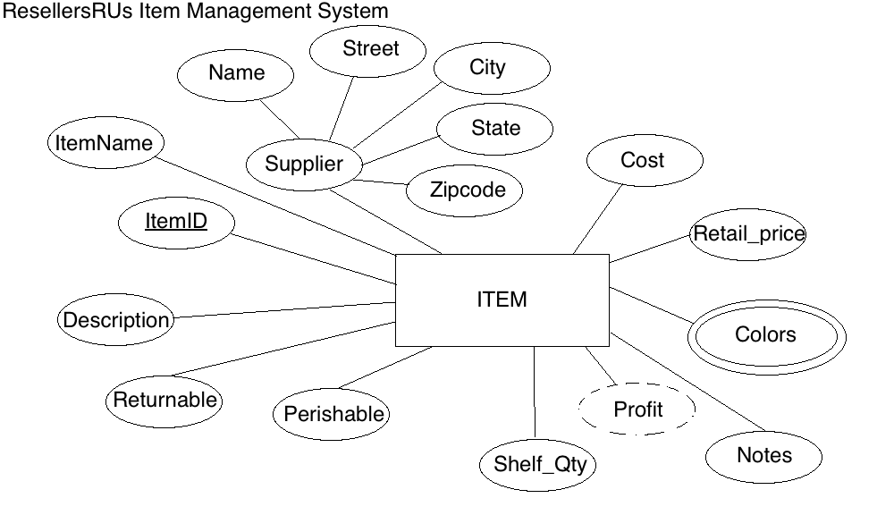

Resulting Relation:

ITEM(ItemID, ItemName, Name, Street, City, State, Zipcode, Cost, Retail_price, Color1, Color2, Notes, Shelf_Qty, Perishable, Returnable, Description)

Functional Dependencies:

ItemID 🡺 ItemName, Name, Street, City, State, Zipcode, Cost, Retail_price, Color1, Color2, Notes, Shelf_Qty, Perishable, Returnable, Description

Name 🡺 Street, City, State, Zipcode

**YOUR ANSWER (Final set of relations normalized to BCNF):**

ITEM(ItemID, ItemName, *Name*, Cost, Retail_price, Notes, Shelf_Qty, Perishable, Returnable, Description)

ITEM (Name) mei SUPPLIER (Name)

COLOR(Color)

SUPPLIER (Name , Street, City, State, Zipcode)

ITEMCOLOR (*ItemID* , *Color*)

ITEMCOLOR(ItemID) mei ITEM(ItemID)

ITEMCOLOR(Color) mei COLOR(Color)

**Task #5 (23 points)**

Given the relation and functional dependencies below, normalize the SALE relation and resulting relations through BCNF. Be sure to use proper relational notation and reference statements for foreign keys.

SALE(Invoice#, Item#, CustID, CustName, CustAddress, ItemName, ItemPrice, ItemQtyPurch, Salesperson#, SalespersonName, Subtotal, Tax, TotalDue)

Functional Dependencies:

Invoice#, Item# 🡪 CustID, CustName, CustAddress, ItemName, ItemPrice, ItemQtyPurch, Salesperson#, SalespersonName, Subtotal, Tax, TotalDue

Item# 🡪 ItemName, ItemPrice

Invoice# 🡪 CustID, CustName, CustAddress, Salesperson#, SalespersonName, Subtotal, Tax, TotalDue

CustID 🡪 CustName, CustAddress

Salesperson# 🡪 SalespersonName

**YOUR ANSWER (Final set of relations normalized to BCNF):**

SALE (*Invoice#* , *Item#*, ItemQtyPurch)

SALE (Item#) mei ITEM (Item#)

SALE (Invoice#) mei INVOICE(Invoice#)

ITEM (Item#, ItemName, ItemPrice)

CUSTOMER (CustID, CustName, CustAddress )

SALESPERSON (Salesperson#, SalespersonName)

INVOICE(Invoice# , *CustID*, *Salesperson#*, Subtotal, Tax, TotalDue )

INVOICE (CustID) mei CUSTOMER (CustID)

INVOICE (Salesperson#) mei SALESPERSON (Salesperson#)

**Task #6 (27 points)**

Given the relation and functional dependencies below, normalize the relation and resulting relations through BCNF. Be sure to use proper relational notation and reference statements for foreign keys.

A(1, 2, 3, 4, 5, 6, 7, 8, 9, 10)

Functional Dependencies:

1, 2, 3, 4->5, 6, 7, 8, 9, 10

1->5, 6

5->1,6

2,3->7,8

7->8

4->9,10

9->10

10->9

**YOUR ANSWER (Final set of relations normalized to BCNF):**

A(*1*,*2*,*3*,*4*)

A(1) mei B(1)

A(2,3) mei D(2,3)

A(4) mei F(4)

B(1,*5*)

B(5) mei C(5)

C(5,6)

D(2,3,*7*)

D(7) mei E(7)

E(7,8)

F(4,*9*)

F(9) mei G(9)

G(9,10)